MODULE 1 & 2

Module 1: Foundations Prompt Engineering!
If you’re totally new to prompt engineering, no stress at all. Think of me as your friendly guide sitting right next to you. We’re going to go slow with real-life examples so everything clicks instantly. By the end, you’ll actually understand what prompt engineering is and exactly how it works.
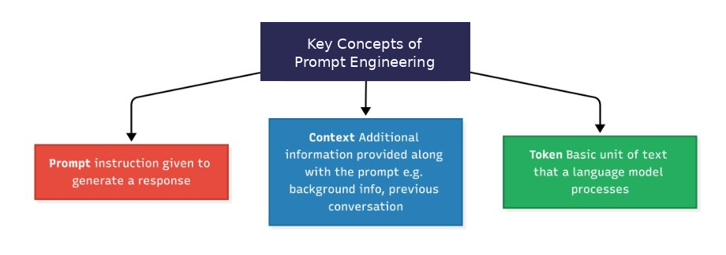
image_fixed.png

1.1 Introduction to Prompt Engineering

1.1.1 What is Prompt Engineering
Prompt Engineering is the science of articulating your vision in a way that the large language models (LLMs) and vision-language models (VLMs) can understand and generate the desired output. It involves strategically designing task-specific instructions to guide the model output.
Think of it as a super-smart friend who can write stories, answer questions, or even design things, but he takes every single word you say literally. Say something vague like “make me something nice” and you might get a random weird answer. But explain it step-by-step with all the details? Boom, perfect result every time!

1.1.2 Role of prompts in LLMs
Prompts are the primary way to control and improve LLM outputs. Without good ones, you just get boring, generic replies.
Do you know? Even big companies use prompt engineering instead of expensive model retraining. It’s like teaching the AI new tricks without touching its brain!
Here’s a quick tip: the clearer your prompt, the better the answer. But don’t go crazy long, too many details can confuse the AI and make it “hallucinate” (make stuff up). Balance is the secret sauce.

1.1.3 Prompt structure
Let’s see the magic with a real example. I’ll show you a bad prompt first, then the good one, and I even turned it into a simple flowchart so you can see why it works.
Vague prompt:
“Customer is angry about late delivery. Respond.”
Structured prompt:
“You are a senior customer support executive of an e-commerce brand. A customer is angry because their order is 3 days late. Tone: apologetic and solution-focused. Include: apology + reason + compensation offer + reassurance. Limit: 3 lines.”
See the difference? The good one has three clear parts:
- Instruction
- Context
- Input
Here’s a flowchart that shows exactly how this works:

1.1.4 Tokenization and context windows
LLMs don’t read words like we do. They break text into pieces called tokens (about 3/4 of a word). They also have a memory limit called a context window.
Example:
- Token: “Hello!” = 2 tokens ([“Hello”, “!”]). “I’m learning.” = 4 tokens ([“I”, “’”, “m”, " learning“,”."]).
- Context Window: If a model has a 128K token window, it’s like a notebook with 128,000 lines. Every prompt you give and reply it writes fills lines in this notebook. When it’s full, it can’t remember anything from the first page.
“A ‘token’ is ~4 characters of text; models have hard limits (e.g., 128K tokens) on how much context they can process at once.”
Here’s a visual of how tokenization actually happens:
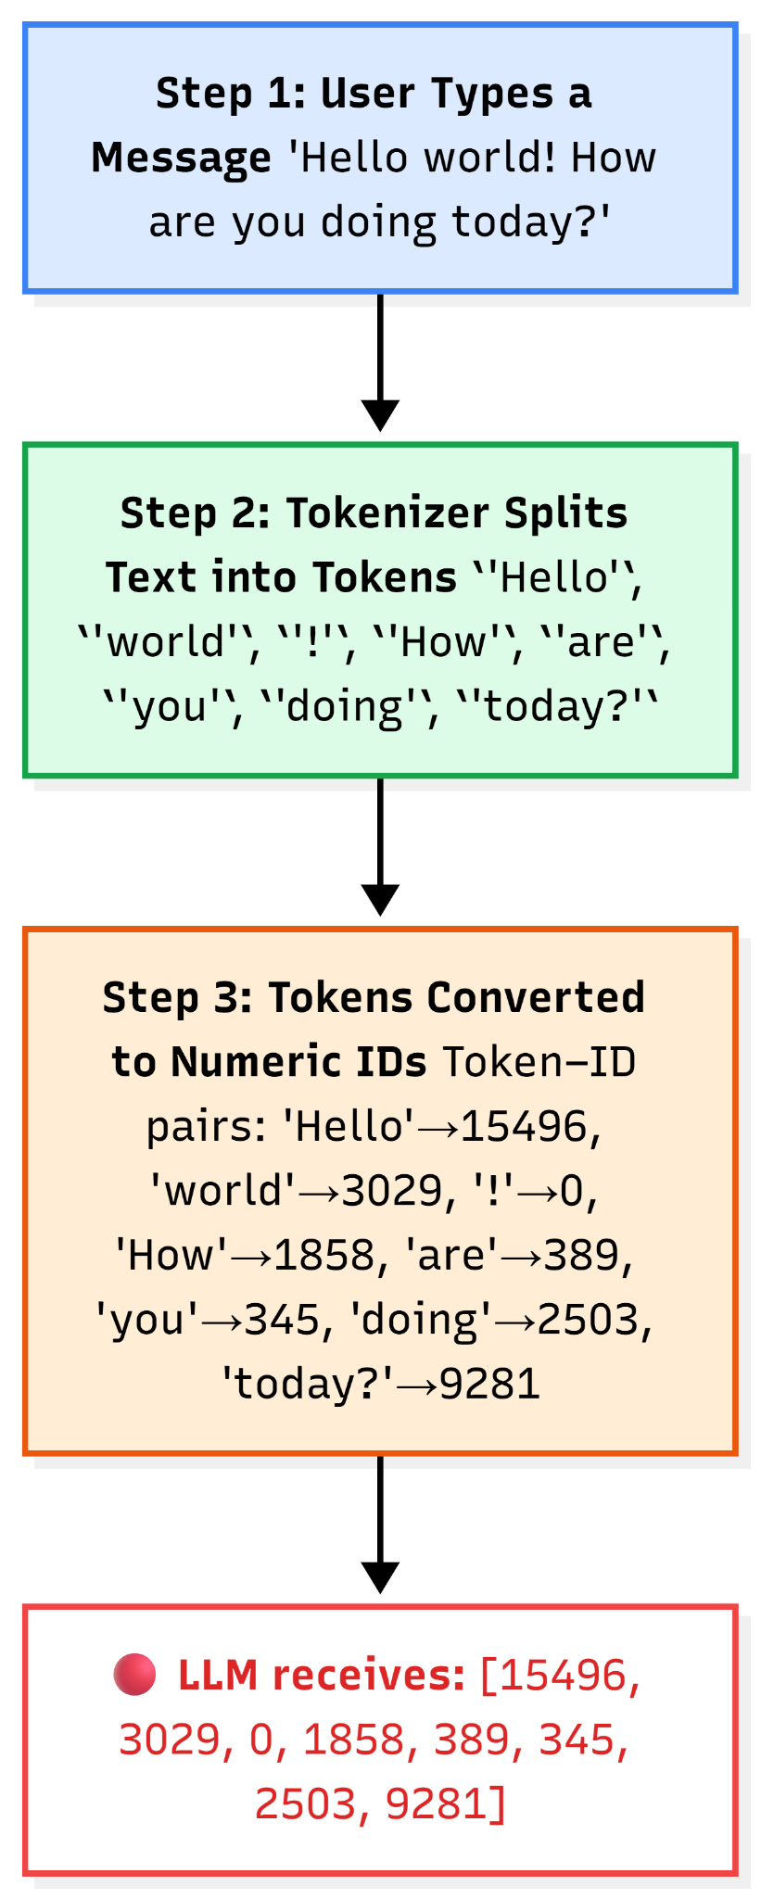

1.2 Context Engineering
Now let’s level up! While prompt engineering is about writing good instructions, context engineering is about carefully designing and managing all the information the LLM sees in its “working memory” (the context window) so it can give better, more accurate, and consistent answers. It includes not just the prompt, but also extra details like past chats, important facts from documents, rules, tools, or user info.

1.2.1 Prompt vs Context
Think of it like this:
- Prompt: The direct message you send to LLM.
- Context: Everything (past chats, retrieved docs, etc.) send to the LLM along with the prompt.
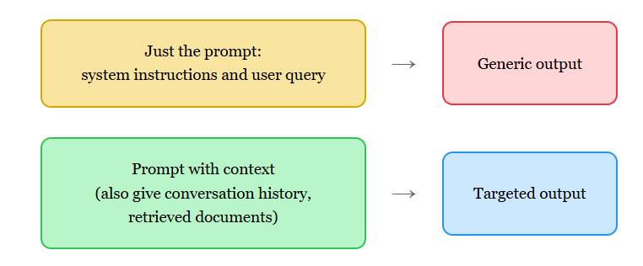

1.2.2 Structuring LLM inputs
LLM inputs (what goes into the context window) work best when organized clearly, like sections in a book. Good structure helps the model find and use information easily, reduces confusion, and gives better results.
Common way to structure:
- System instructions: Role and rules (e.g., “You are a helpful chef. Always be safe and list ingredients first.”)
- Examples: Show what good answers look like.
- Retrieved or extra knowledge: Facts or documents needed for this task.
- Conversation history: Past messages so it remembers the chat.
- User question/input: What the user asks now.
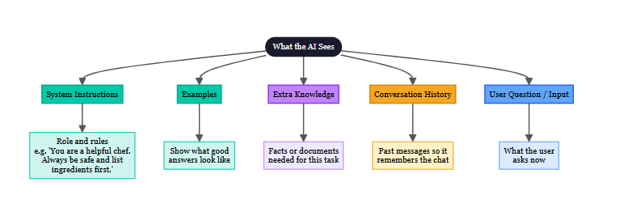

1.2.3 Memory, instructions, and external knowledge
These are the three magic ingredients that fill the context window:
- Instructions: Your job description for the AI
- Memory: Short-term (this chat) + Long-term (user likes spicy food, hates onions)
- External knowledge: Latest prices, documents, etc.
A meal-kit chatbot uses all three to never suggest onion recipes again.

1.3 Entity & Characterization
Entity & characterization is about giving the model a clear “identity” and specific details so it behaves consistently and understands exactly who or what it’s supposed to represent. This helps the chatbot feel like a real helpful person (or expert) instead of a boring robot. It makes responses more engaging, trustworthy, and tailored to the user’s needs.

1.3.1 Attribute-based prompting
Instead of saying “find me a laptop,” you list exact must-haves:
"Recommend laptops with these attributes:
- Price: under ₹60,000
- Screen: 15-inch or larger
- RAM: at least 16GB
- Use: for college students (light gaming + studies)
- Battery: 6+ hours Prioritize brands like Lenovo, HP, Dell. Include why each matches the attributes."

1.3.2 Persona prompting
Persona prompting means giving the model a full character or persona — like a name, age, style, tone, background, and attitude. The AI “becomes” that persona and answers as if it’s a real person with that personality.
Example:
"You are Priya, a 28-year-old fashion-loving shopping assistant for a store in Mumbai.
- Tone: super friendly, excited, like chatting with a best friend.
- Style: trendy, honest — tell if something doesn’t suit.
- Expertise: women’s ethnic wear, fusion outfits, budget tips.
- Goal: help customers look amazing without overspending. ”

1.3.3 Structured role definition
You are the official customer support & shopping assistant.
Role & Goals
- Main job: Answer questions, recommend products, track orders, handle returns/complaints.
- Goal: Make shopping easy, fun, and trustworthy. Increase customer happiness and sales.
Tone & Style
- Friendly, polite, professional yet warm.
- Use a simple Hindi-English mix if the user speaks Hindi.
- Short answers (4–7 sentences max unless asked for more).
- Always positive — never argue.
Rules
- Never promise delivery times without checking real status.
- If out of stock, suggest similar items.
- For complaints: apologize first, then solve.
- End with: “Anything else I can help with?”
Tools / Access
- Can check order status, stock, prices from the database.

MODULE 2:

Basic Prompting Techniques
If you just finished Module 1, you’re already ahead of most people. Now we’re going to learn about basic prompting techniques.
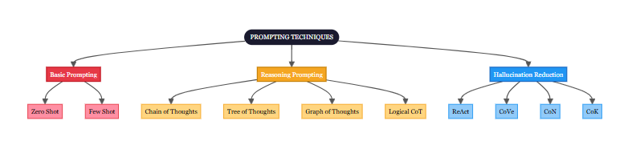

2.1 Zero-Shot Prompting
This is the simplest method where you give a direct instruction without any examples. Here, the model relies on prior knowledge to infer the task structure.
How it works: You have to state what you need clearly. To obtain high-quality zero-shot responses, the prompt should clearly define the task, provide necessary context, specify constraints, and indicate the desired output format. Optionally, assigning a role can help the model adopt domain-specific behavior.
Example 1:
instruction: Extract the "Fields" from the text
fields:
- Name
- Email
- Phone
- Skills
input_text: "<PASTE TEXT>"
Example 2: Generating product descriptions for an e-commerce store
Role: You are a professional e-commerce copywriter. Write a persuasive and engaging product description for an online store.
Context: Audience is online shoppers aged 18–35 looking for trendy, value-for-money products
Product: Wireless neckband earphones
Description:
- Fast charging
- IPX5 water resistance
- 30-hour battery life
- Deep bass sound
Requirements:
- Highlight the most attractive features
- Include 3 clear customer benefits
- Add 1 short emotional or lifestyle hook (e.g., how it fits into daily life)
- Tone: friendly, confident, and exciting (but not exaggerated)
- Length: 140–180 words
Output Format:
- Product Name
- One main paragraph
- One short bullet-point list of key features
- One closing call-to-action line
When to use it: For straightforward tasks where the topic is well known. It’s quick but might not handle complex questions perfectly.
Pros and Cons:
- Pros: Fast and easy—no extra setup.
- Cons: Can lead to errors for niche questions.

Here’s exactly how zero-shot works:
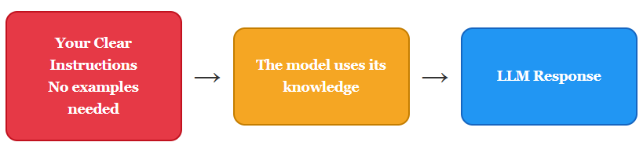

2.2 Few-Shot Prompting
In this, a few examples are provided before asking the actual question. This helps the model learn the pattern from the examples and apply it.
How it works: Provide labelled input-output pairs, before asking the actual question.
Example 1: Writing Product Descriptions in Brand Voice
{
"role": "You are a copywriter for an online store for young people. Write short, catchy product descriptions (80–110 words).",
"rules": [
"Start with a fun hook",
"List 2–3 key benefits",
"End with an inviting phrase",
"Tone: casual, energetic (with emojis sometimes)"
],
"few_shot_examples": [
{
"product": "Blue Denim Jacket",
"description": "Ready to level up your street style? This classic blue denim jacket is your new go-to layer. Super soft cotton, relaxed fit, and cool distressed details. Perfect for college hangs or weekend vibes. Grab it before it's gone!"
},
{
"product": "Wireless Sport Earbuds",
"description": "Pump up your workout playlist! Sweat-proof earbuds with powerful bass and 8-hour battery life. Stay-secure hooks + quick Bluetooth pairing. Whether you're running or hitting the gym — these keep the energy high. Get moving today!"
}
],
"input_product_name": "<input question>"
}
Example 2: Explaining Common E-commerce Acronyms to new developers / marketers
{
"instruction": "Explain e-commerce acronyms to newcomers in online stores.",
"output_format": "'[ACRONYM]' means '[Full form]'. It refers to [short one-sentence explanation].",
"few_shot_examples": [
{
"acronym": "AOV",
"full_form": "Average Order Value",
"explanation": "The average amount a customer spends per order in your store."
},
{
"acronym": "CAC",
"full_form": "Customer Acquisition Cost",
"explanation": "The total money spent to get one new customer (ads + marketing)."
}
],
"input_acronym_name": "CLV"
}
When to use it: For tasks like classification or creative writing where patterns matter.
Pros and Cons:
- Pros: Improves accuracy by giving context.
- Cons: Requires thinking up good examples, too many examples can confuse the model.

Here’s a visual flowchart of how few-shot beats zero-shot:
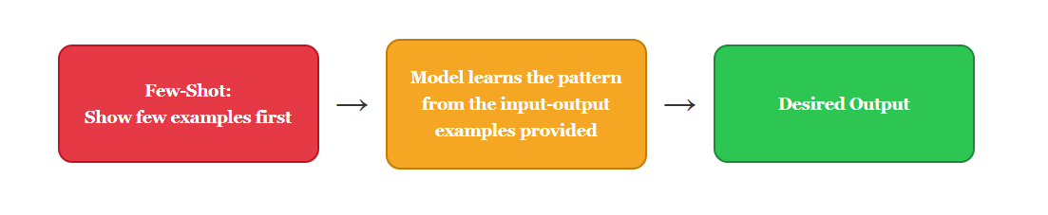

2.3 Prompt Templates
Prompt templates are ready-made reusable formats with placeholders (like [product_name]). You fill in the blanks for each use. They save time, keep consistency, and make it easy to scale.

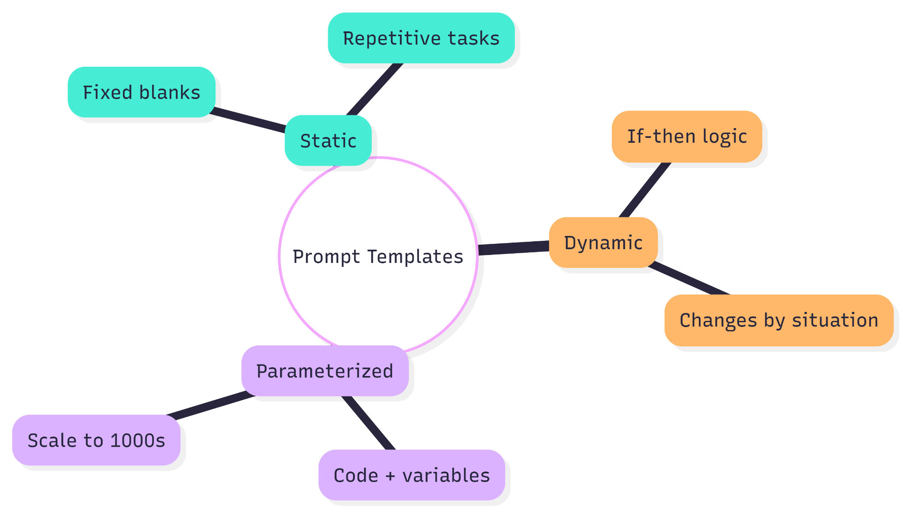

2.3.1 Static templates
They have a fixed format with a few fill-in spots which is the user input or variable value. They are best for repetitive tasks with very similar outputs.
Example:
# Product Description Prompt
## Task
Write a short, exciting product description for **[product_name]**.
## Highlight
Focus on the following key features:
- **[key_feature1]**
- **[key_feature2]**
## Rules
- Keep the description under **100 words**.
## Call to Action
End the description with a clear call to action such as **"Order now!"**.

2.3.2 Dynamic templates
The template itself can change based on conditions (if-then logic). Different paths for different product categories or customer types.
Example:
# Customer Support Dynamic Prompt
## Persona
You are **[PERSONA]** for **[BRAND_NAME]**.
## Input
Customer Query: **[QUERY]**
## Logic
**If the query is about order status**
- Check the order tracking information.
- Provide the latest update.
- Respond politely and include a brief apology for any delay.
**If the query is about product recommendations**
- Suggest **2–3 suitable products**.
- Include **product names and prices**.
- Keep the tone friendly and helpful.
**If the query is a complaint**
- Start with a **clear apology**.
- Acknowledge the issue.
- Offer a **solution or next step** (refund, replacement, or support).
## Response Guidelines
- Be polite and helpful.
- Keep responses clear and concise.
- Focus on solving the customer's problem quickly.

2.3.3 Parameterized prompts (for pros)
These are templates with many variables, usually built in code. You pass values programmatically.
Example
# Parameterized SEO Meta Generator Prompt
## Overview
This prompt template generates **SEO-optimized meta titles and meta descriptions** for product pages.
It is **parameterized**, meaning product data can be inserted dynamically to automatically generate metadata for large product catalogs.
# Prompt Template
Create an SEO-optimized:
- meta title (max 60 characters)
- meta description (max 160 characters)
Inputs:
Product Name: {product_name}
Price: ₹{price}
Key benefits: {benefit1}, {benefit2}
Target keywords: {keyword1}, {keyword2}
Brand tone: {tone}
# Parameters
| Parameter | Description | Example |
|-----------|-------------|--------|
| `product_name` | Name of the product | Wireless Neckband Earphones |
| `price` | Product price in INR | 1999 |
| `benefit1` | Primary benefit of the product | 30-hour battery life |
| `benefit2` | Secondary benefit | deep bass sound |
| `keyword1` | Primary SEO keyword | wireless neckband |
| `keyword2` | Secondary SEO keyword | bluetooth earphones |
| `tone` | Brand voice/style | energetic |
# Automation Workflow
Example automated pipeline:
1. Load product catalog from **CSV / database**
2. Loop through each product
3. Insert product values into the prompt parameters
4. Send prompt to an **LLM API**
5. Save generated metadata to the catalog
It can loop through your product catalog and generate thousands of titles/descriptions automatically.

2.4 Prompt Evaluation
After writing prompts, you must test how good they are. Evaluation checks if the model gives reliable, fair, and strong answers.

2.4.1 Accuracy
It is how often the output is correct (facts right, task done properly).
Example: Test 100 product recommendation prompts. Count how many times suggestions were actually in stock, matched price budget, and relevant. Goal: >90% accuracy → means customers get useful suggestions, leading to more sales.
Formula:
$$\text{Accuracy}=\left(\frac{\text{Number of Correct / Useful Outputs}}{\text{Total Number of Test Cases}}\right)×100\%$$

2.4.2 Bias
It checks if the model favors certain groups unfairly (e.g., gender, age, region) or uses unfair language.
Example: Test prompts for clothing suggestions. If the model always suggests “slim-fit” only for young users or avoids certain styles for specific names/locations, that’s bias. Fix: Add rules like “Suggest diverse styles for all body types and preferences.”
Bias Score:
$$\text{Bias Score}=|\text{Positive Rate for Group A}−\text{Positive Rate for Group B}|$$
(0 = perfectly fair, higher number = more bias)

2.4.3 Robustness
It tells how well the prompt works with tricky, unusual, or slightly wrong inputs (typos, vague questions, edge cases).
Example: Test variations
- “Best phone under 20000?” (normal)
- “best phone under 20k plz” (typos)
- “cheap good phone” (vague)
- “phone for my grandma” (specific but different)
Robust prompt handles all and gives sensible answers without crashing or hallucinating.
Formula:
$$\text{Robustness Score}=\left(\frac{\text{Number of Successful Handles on Perturbed Inputs}}{\text{Total Perturbed Test Cases}}\right)×100\%$$

Here’s a quick evaluation flowchart so you can test your own prompts:
